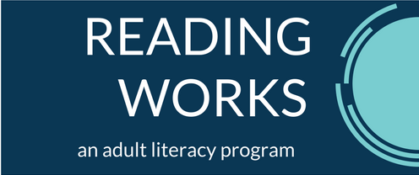

VOLUNTEER APPLICANT REFERENCE QUESTIONS
How do you know this applicant?
What skills and talents do you think this applicant will bring to Reading Works?
Will this applicant be able to work with people of different socioeconomic and cultural backgrounds?
Is there anything else you want to tell us about the applicant that is relevant to volunteering for a non-profit adult literacy program?

Please mail your reference letters to
Reading Works
8005 Pennsylvania Circle NE, Suite C
Albuquerque, NM 87110
or
email your reference letters to
Cindy Ketchum
cindy@reading-works.org

